EXPRESSION OF INTEREST (including Pre-Qualification Requirements)

Provision of Pigging Services
Reference: #001887
BIDS Categories: 5960
Issue Date: July 24, 2018
Closing Date: August 13, 2018
----------------------------------------------------------------------------------------------

Overview:
- Hibernia Management and Development Company Ltd. (HMDC) and ExxonMobil Canada Properties, by its managing partner ExxonMobil Canada Ltd. (ExxonMobil) are in the process of pre-qualifying companies who can supply Pigging Services for their offshore Newfoundland and Labrador requirements.
- Contractor shall provide all management, personnel, processes, materials, tools, equipment, applicable certifications and facilities as may be required to ensure all equipment covered by this pending Contract shall be fabricated and supplied to meet all statutory requirements, codes of practice and applicable specifications.
- The intention is to have this scope of work cover the requirements of the Hibernia Project* and the Hebron Project. For clarity, the scope of work includes not only the foregoing, but may include at ExxonMobil and/or HMDC’s discretion, future work related to minor changes to the scope of work described herein, in which ExxonMobil and/or HMDC may engage onshore or offshore Nova Scotia and Newfoundland and Labrador, for oil and gas facilities, as well as potential Exploration activities.
- While not planned, it should be noted that the resulting RFP and contract may require inclusion of and/or extension to other operators in the area, project co-venturers, contractors and/or affiliated companies.
- For work related to the Hibernia Project*, HMDC supports providing opportunities to Canadian, and, in particular, Newfoundland and Labrador companies and individuals, on a commercially competitive basis. Contractors expressing interest in providing services or materials, if they are selected to bid, will be required to complete a Canada-Newfoundland and Labrador Benefits Questionnaire at the bid stage.
- For work related to the Hebron Project, ExxonMobil supports providing opportunities to Canadian, and, in particular, Newfoundland and Labrador companies and individuals, on a commercially competitive basis. Contractors expressing interest in providing services or materials, if they are selected to bid, will be required to complete a Canada-Newfoundland and Labrador Benefits Questionnaire at the bid stage.
- HMDC and ExxonMobil encourage the participation of members of designated groups (women; Aboriginal peoples; persons with disabilities; and members of visible minorities) and corporations or cooperatives owned by them, in the supply of goods and services.

Supplier Diversity

Diverse Ownership (Completion of this section is voluntary)
A Diverse supplier is a business that is at least 51 % owned and controlled by a member(s) of one or more of the four designated groups identified in Canadian employment equity legislation:
☐ Women
☐ Aboriginal peoples
☐ Visible Minorities
☐ Persons with disabilities
Please indicate above which designated group(s) are applicable to your business.

Certification for Diverse Businesses

There are currently national certifying organizations that cover certification for businesses owned by:
• Aboriginal Peoples
• Visible Minorities
• Women

The Projects will continue to look for organizations that can provide certification support to businesses owned by persons with disabilities.

If you indicated that your business is owned by a member of a designated group, are you currently certified as a diverse-owned business? ☐Yes ☐ No

Through which certifying organization is your business certified? ______________________________

If you are a NL registered business and are not currently certified, would you be interested in learning more about certification? ☐Yes ☐ No
The Hebron Project has a vendor database that is used to identify possible suppliers and contractors to participate in the project. Suppliers and contractors are encouraged to register.
ExxonMobil, operator of the Hebron Project, will use the database beyond development/construction, into the operations phase of the project. We also see value in expanding use of the database to the Hibernia and Hibernia Southern Extension projects, as well as project co-venturers and co-owners should they request information. The increased visibility to three major projects and other noted industry participants may be of value to your organization as it has the potential to increase future procurement opportunities.
DISCLAIMER: By registering your company in the vendor database, you are consenting to making your information available to the parties noted above in addition to the Hebron Project.
NOTE: Registration in the database does not imply that a supplier or contractor is approved as a qualified supplier, nor does it indicate that a supplier or contractor is included on any tender or bid list for the supply of goods or services for which it has registered.

Scope of Work Overview:

The scope of work/supply includes, but is not limited to:

The provision of pipeline cleaning and in-line inspection (ILI) services for offshore natural gas (NG) and crude pipelines up to and including 26” in diameter. These services include the development of a successful pigging program (both cleaning and ILI), the provision of all cleaning and ILI tooling (various designs/technologies), as well as competent technicians to travel offshore to support the execution of the pigging program. This scope also includes the provision of technical services to support planning, executing, troubleshooting, and data analysis/fitness-for-service for cleaning and ILI pigging.

Additionally, the selected contractor will be required to meet all technical and Safety, Health, Environmental, and Security (SHE&S) specifications and safe work practices of ExxonMobil, HMDC, and their affiliates as appropriate.

Minimum Technical Requirements
Contractor shall demonstrate, at a minimum, that they meet the below list of technical requirements:

- In-country technical and field service technicians.

- Provision of tools that are capable of carrying out the types of inspections/technologies listed in the below table.

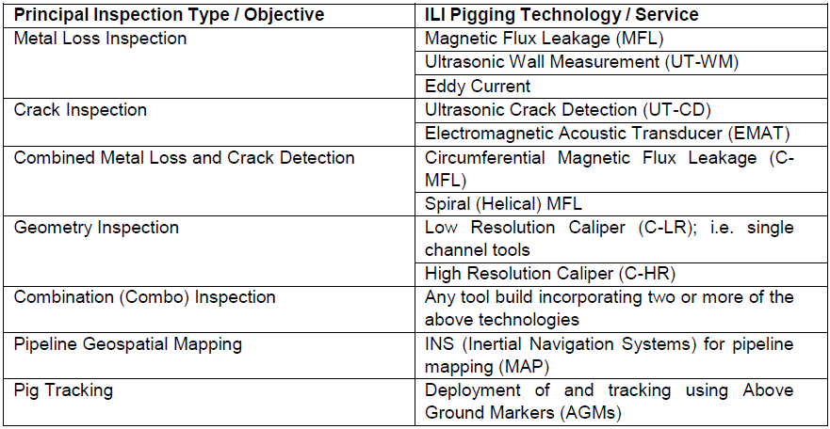

- Provision of various types of cleaning tools (cup, bi-directional, etc.) that are able to clean NG and crude oil pipelines to an acceptable level prior to ILI pigging.

- Provide confirmation that the Contractor is familiar with the following industry best practices, codes and standards:
- Pipeline Operators Forum (POF) document “Specifications and Requirements for Intelligent Pig Inspection of Pipelines Version 2009 – D1”
- API Standard 1163 Second Edition, April 2013: In-line Inspection Systems Qualification
- ANSI/ASNT ILI-PQ-2010: In-line Inspection Personnel Qualification and Certification Standard
- ASME B31.4-2012: Pipeline Transportation Systems for Liquids and Slurries
- BS 7910:2013: Guide on methods for assessing the acceptability of flaws in metallic structures
- Canadian Energy Pipeline Association (CEPA), Stress Corrosion Cracking – Recommended Practices, 2nd edition, December 2007
- API 579 Second Edition, June 2007: Fitness-For-Service
- PRCI Report PR-218-9304 – Continued Validation of RSTRENG
- NACE SP0102-2010: In-Line Inspection of Pipelines

Contractor shall provide CV’s for competent technical and field service technicians who have experience conducting cleaning and ILI pigging operations for offshore natural gas and crude oil pipelines.
Submission Requirements
Vendor submissions in response to this Expression of Interest (including pre-qualification) must include the afore-mentioned reference number, as well as the following information:
1. Completed ExxonMobil / HMDC Vendor SHE pre-qualification questionnaire. (Available through BIDS – see contact information below.)
2. Completed ExxonMobil / HMDC QA/QC pre-qualification questionnaire. (Available through BIDS-see contact information below.)
3. Information demonstrating qualification for the Scope of Work detailed above.
4. Information demonstrating vendor can meet minimum technical requirements detailed above
5. Completed technical questionnaire. (Available through BIDS – see contact information below.)
6. Describe your experience operating under and familiarity with, the benefits provisions of the Canada-Newfoundland and Labrador Atlantic Accord Implementation Act and your experience with any similar regimes in other parts of Canada or internationally. At the RFP/ITT stage, bidders will be required to indicate how they comply with the above.

7. Please acknowledge that responsible management personnel have read, understand and will support requirements to comply with the following where applicable
i) Section 45 of the Canada-Newfoundland and Labrador Atlantic Accord Implementation Act
ii) Section 45 of the Canada-Nova Scotia Offshore Petroleum Resources Accord Implementation Act
iii) The Hebron Benefits Agreement and Hebron Benefits Plan work requirements
iv) The HSE Benefits Agreement and HSE Benefits Plan work requirements

The data submitted in response to the aforementioned questionnaires will be used to evaluate your company’s ability (and those of your preferred sub-contractors / vendors where applicable) to perform these services or provide these materials.
It will focus primarily on:
- Past safety performance
- Applicable experiences
- Project execution skills
- Project management skills & integration skills
- Available technologies with proven performance
- Current capability

We will evaluate this data and develop a final group of vendors who will be asked to submit formal competitive bids. We reserve the right to make the final determination of which contractors will receive the Request for Proposals (RFP) or Invitation to Tender (ITT) and which contractor will be awarded the final contract.
This Expression of Interest (including pre-qualification) is not a pre-qualification of contractors for other ExxonMobil /HMDC work, but is limited to the scope aforementioned. In addition, participation in this Expression of Interest (including pre-qualification), including any statements whether oral or written between ExxonMobil / HMDC and your company, shall not create or be deemed to create any binding legal relationship or contract, or be construed to do so between ExxonMobil / HMDC and your company. All costs associated with the preparation of your response to this expression of interest shall be at your expense.
This Expression of Interest (including pre-qualification) may or may not result in the issuance of an RFP/ITT and may or may not result in the award of a contract. If you respond to this Expression of Interest (including pre-qualification) and your company is selected to be on the bidders list, your company name, your designated company representative’s name and business contact information may be posted on public websites. Similarly, if you are selected for award, the same information may also be posted, indicating that the work has been awarded to your company.
* It should be assumed that the Hibernia Project includes, but is not limited to, current and planned Hibernia and Hibernia Southern Extension operations as well as future development on behalf of Hibernia (operated by Hibernia Management and Development Company Ltd.) and/or Hibernia Southern Extension participants (operated by ExxonMobil Canada Properties).
Responses must be submitted electronically by the closing date to all of the ExxonMobil or HMDC e-mail addresses noted below:

Attention: Samantha McGrath
Title: Procurement Associate
Email: Samantha.d.mcgrath@esso.ca
Telephone: (709)-273-1630

Finally, potential vendors, if they have not already done so, should register with BIDS using following contact information:

Phone: 1-800-270-4611
E-mail: jayde.mcconchie@bids.ca
www.bids.ca

